Steps to normalize

1. Import into new database via task wizard

2. Create Primary Key

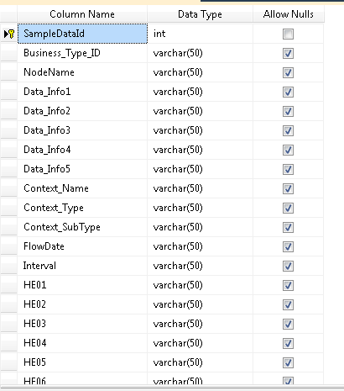

3. Create table to store each datetime and corresponding value with foreign key

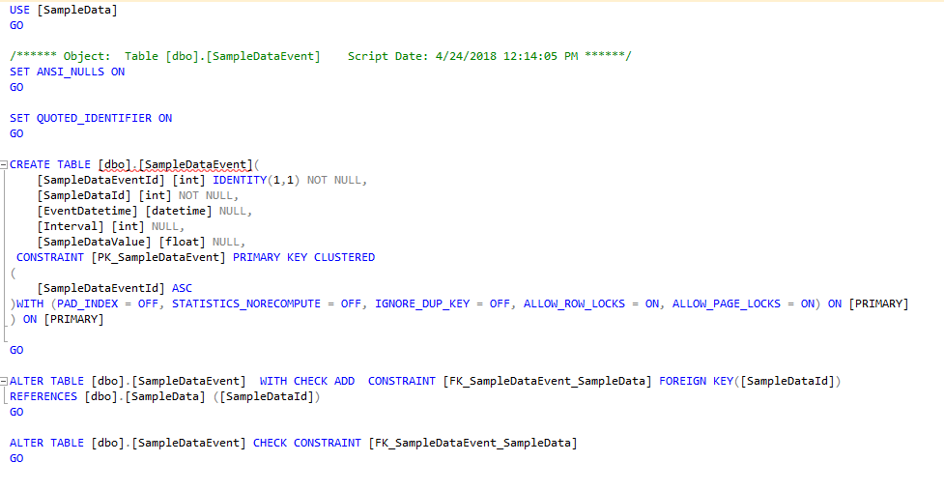

**4. Script to insert**

Use SampleData

declare @columnHour int = 1;

declare @columnName varchar(2) ='';

declare @query varchar(max);

while (@columnHour<25)

begin

if @columnHour<10

begin

set @ColumnName+='0';

end

set @columnName = @columnName+convert(varchar,@columnHour);

--print @ColumnName;

set @query='

insert into SampleDataEvent

select [SampleDataId],

FlowDate+'' ''+'''+@columnName+'''+'':''+ right (''00''+ltrim(str( Interval )),2 ) as [EventDateTime],

Interval,

HE'+@columnName+' as Value

from SampleData';

--print @query;

execute(@query);

set @columnHour+=1;

end

Results:

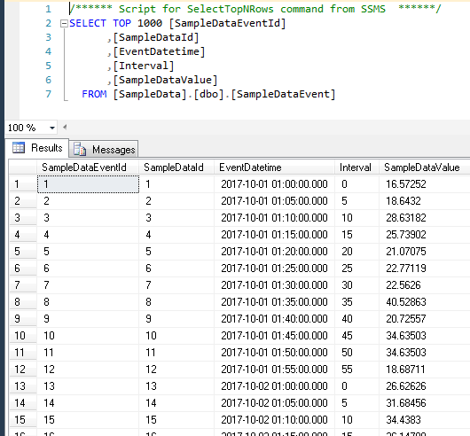

5. Script for first view

USE SampleData

GO

SET ANSI_NULLS ON

GO

SET QUOTED_IDENTIFIER ON

GO

CREATE VIEW [dbo].ViewEvents

AS

select

sd.SampleDataId

,[Business_Type_ID]

,[NodeName]

,[Data_Info1]

,[Data_Info2]

,[Data_Info3]

,[Data_Info4]

,[Data_Info5]

,[Context_Name]

,[Context_Type]

,[Context_SubType]

,[EventDatetime]

,sde.[Interval]

,[SampleDataValue]

from

SampleData sd

join

SampleDataEvent sde

on sd.SampleDataId = sde.SampleDataId

GO

Results:

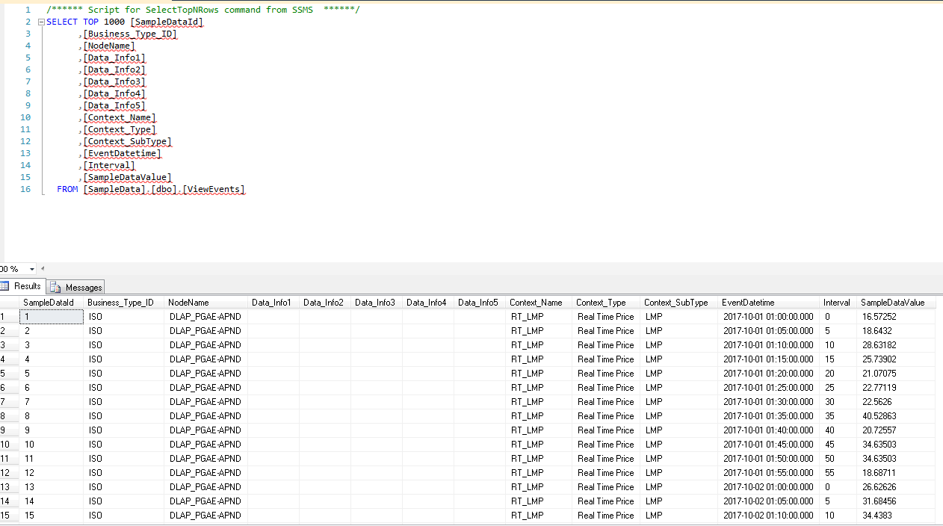

6. Create View for group by for Sum and Avg (Rounded to five for initial precision)

USE [SampleData]

GO

/****** Object: View [dbo].[ViewEventsSumAvg] Script Date: 4/24/2018 12:12:43 PM ******/

SET ANSI_NULLS ON

GO

SET QUOTED_IDENTIFIER ON

GO

CREATE VIEW [dbo].[ViewEventsSumAvg]

AS

SELECT

EventDatetime

,Interval

,round(sum(SampleDataValue),5) as [Sum Values]

,round(avg(SampleDataValue),5) as [Avg Values]

FROM ViewEvents

group by

EventDatetime,Interval

GO

Results:

